**ASSIGNMENT**

**GIT URL :** [**https://github.com/Tejasaiandem06/Assign.git**](https://github.com/Tejasaiandem06/Assign.git)

**AZURE VM**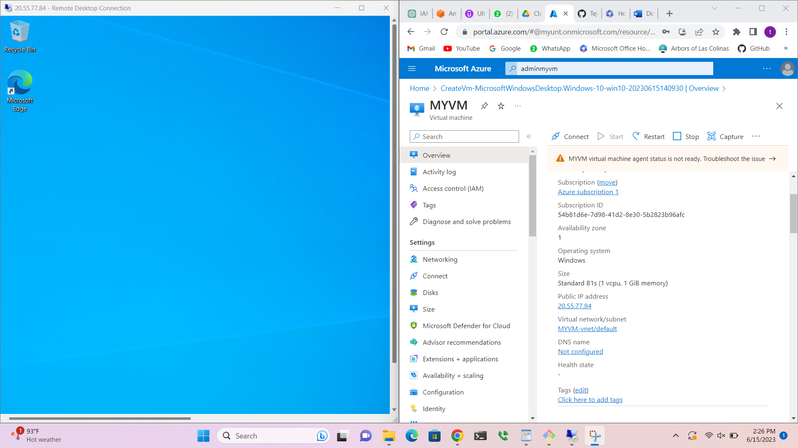

**GIT REPOS**

